- What were some of the major geologic processes that helped shape the Rocky Mountains into such a spectacular range of dramatic peaks and both U-shaped and V-shaped valleys?
There were Tectonic forces that began moving the north America plate westwards in about 200 million years ago which collided with the pacific plate and this collision force, called the Colombia Orogeny, moved east over North America forcing the sedimentary layers up and over the adjacent land with cracked enormous masses of rock. Laramide Orogeny was the second collision that ended about 35 to 55 million years ago creating the foothills and the front ranges of the Rocky Mountains. Volcanic activity in the Rocky Mountains were also taking place where volcanic ceased and cooling of magma occurred living calderas. Water flow carried sediment from the mountain into the valleys and plains from the millennia that followed thus creating V-shaped valleys. For instance Hells Canyon at 7800 feet shaped by the River Snake. Glaciation created many of the mountainous west where the glacier reached as far south as the Rockies of New Mexico. Receding of the glacier carved magnificent U-shaped valleys that are much wider than the V-shaped valleys carved by water.

- Why do ecosystems and related plant communities in the Rocky Mountains show evidence of altitudinal zonation while the Appalachian Mountains in eastern North America do not?
The Appalachian Mountains average about 3000 feet in height with the highest peak at approximately 6800 feet, whereas the Rocky Mountains can reach up to about 14,500 feet with vegetation zones at around 4000, 6000, 8000, 10,000, and 12,000 feet.
- What factors accounted for population growth in the Rocky Mountain region from the mid 19th century up to the arrival of retiree migrants and recreationists in more recent years? Search for job was the factor that encountered for population growth where people came to get jobs in mining, forestry, and ranching. Thereafter, Latinos and others moved to the region along to take advantage of the regions lucrative job market. People also migrated to the area for recreational purposes around the mountains which resulted too many national parks, forest and also resorts which were attractive to tourists.

- What factors account for the expanded size of both the population and the economy in the Rocky Mountain region during the past two decades? Tourism and recreational opportunities in the Rocky Mountain regions has led to population growth where many cities such as Denver come to existence. It has also attracted technological development around the area in the companies thus creating job and employment.

- Find a map online that shows the major metropolitan areas of the Rockies. Embed the map into your PA document. List the three major cities in this region. Phoenix in Arizona is the region’s largest city, followed by Denver in Colorado. Las Vegas in Nevada, Tucson in Arizona and Colorado Springs in Colorado are also large metropolitan areas. The largest truly mountain city deep in the region is Boise in Idaho. Salt Lake City in Utah is also a major metropolitan area in the region.

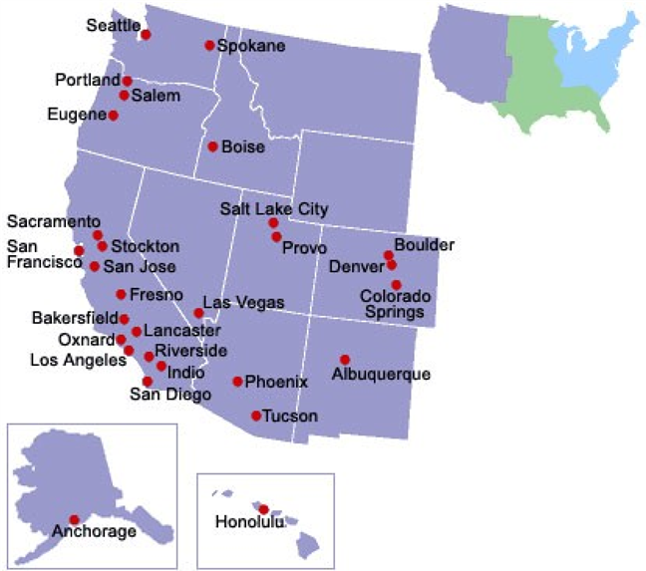

6. What three physiographic sub-regions make up the Intermontane West in the United States?
Basin & Range, Colorado Plateau and the Columbia Plateau
7. What long-term impacts did early Hispanic settlement have on the southern, intermontane region in the United States? Hispanic settlement have Industrialization as long-term impacts on the southern intermountain region in the United States. This has been facilitated by natural resources and dramatic geographical feature that have attracted people. They also have cultural impact witnessed by architectural styles, town plans, culinary and catholic churches.
8. Why did the Latter-day Saints decide to settle in such an isolated part of the United States after being forced to leave their settlement in Illinois? The Mormons settled in Utah because they were chased out of every other place they had previously settled and because Utah was far away from the Oregon Trail and other settlements. Al Mormon leaders also claimed that it had been revealed by God to them that they should settle down in the Rocky Mountains. In a vision from God, Brigham Young had told others that he had seen where they will settle.
9. Why did the Intermontane become such a popular place for retirees and tourists in the late 20th and early 21st centuries?
The area is accessible to many parks and recreational centers with favorable weather conditions of warm winters. Invention of air conditioning also made the area attractive and livable during summer.
10. What are some of the largest national parks in the American Intermontane and where are they located?
Yellowstone National Park in northwestern Wyoming Grand Canyon National Park in Arizona
Canyon lands National Park in Utah
Zion National Park in southwestern Utah
Bryce Canyon National Park in south-central Utah
Mesa Verde National Park in southwestern Colorado
11. Discussion Board: Find and past a video link to the discussion board about tourism in the Rocky Mountains. Discuss how this form of tourism helps or hurts the region.
https://www.youtube.com/watch?v=j8Sh3UeG9ew
https://www.youtube.com/watch?v=F1AYXQBSnUc
This links show the tourist attraction areas in the Rocky Mountains such as lakes, Chapel on the rock, ultra-modern hotels, Alberta falls and trail ridge road which attracts tourist in the region. The architect form of tourism is the best for the exploration and innovation of new technologies in the area. Glaciation also will help in architect form of tourism. People from the region will benefit from the tourism since it create employment in the area, learning of new technologies and development of urban centers in the area,
Reference:
History & Culture. National Parks Service. https://www.nps.gov/romo/learn/historyculture/index.htm (last accessed 14 March 2017).
[Extra content to reinforce primary reading and answer PA questions.]
Rocky Mountains. 2012. Infoplease. http://www.infoplease.com/encyclopedia/us/rocky-mountains-economy-natural-resources.html (last accessed 14 March 2017).
[Extra content to reinforce primary reading and answer PA questions.]
Kelley, M. B. 2015. This map shows the dominant religious group in every US county (as of 2010). Business Insider. http://www.businessinsider.com/the-religious-makeup-of-america-2015-4 (last accessed 14 March 2017).
[Extra content to reinforce primary reading and answer PA questions.]

